**Germany – Source URL Analysis**

**URL**: <https://www.gesetze-im-internet.de/>

Gesetze im Internet (Laws on the Internet) is the official platform provided by the Federal Ministry of Justice and the Federal Office of Justice. The site contains a repository of legal documents, including Gesetze (Laws) and Verordnungen (Ordinances) and other regulations.

The homepage provides search functions located in the left side of the page, offering two options:

* Titelsuche (Title search) – restricts the search to document titles only.
* Volltextsuche (Full-text search) – retrieves matches from the entire content of documents, including articles and annexes.

It was observed that there is no advanced search functionality with filters for both search options. During the analysis, we primarily used the Title search option as it limits matches strictly to document titles. For the purpose of this analysis, we used the keyword “Biodiversität” (Biodiversity), as shown below.

The results page does not display full metadata. To access the Original Title, we need to click on the result link and choose a format to view the full legislation text. The Source Link can be retrieved from the link address of the “HTML” text. During the analysis, we chose the HTML format for easier translation.

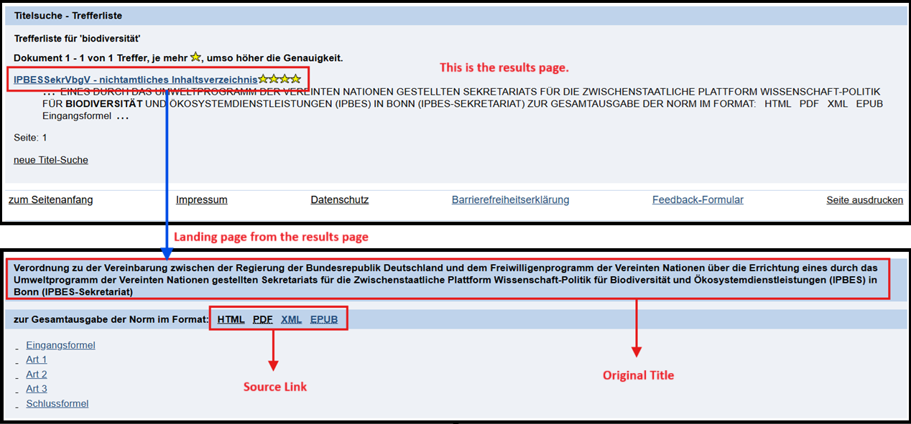

The rest of the metadata (except for the Entry into Force Date) can be retrieved on the full legislation document. The Date of Adoption was inferred from the “Ausfertigungsdatum” (Date of Issue), typically listed at the top of the document. The Type of Regulation is typically indicated at the beginning of the legislation title, as indicated in the example below, where the document title begins with “Verordnung” (Ordinance). For law, it starts with “Gesetz”.

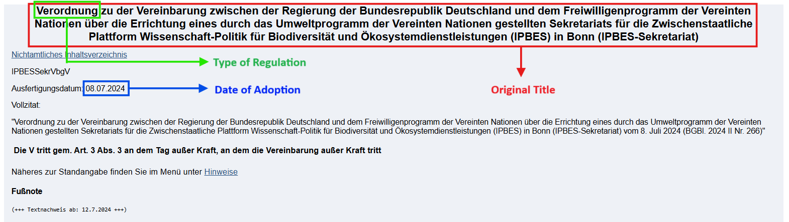

The Entry into Force Date was left blank, as this information is not explicitly provided on the legislation website.

As an additional note, Germany also provides a related platform: <https://www.recht.bund.de/en/home/home_node.html>. It functions more as a centralized legal portal with broader access to German legal publications such as the Bundesgesetzblatt (Federal Law Gazette), where the entry into force date detail is publicly available.